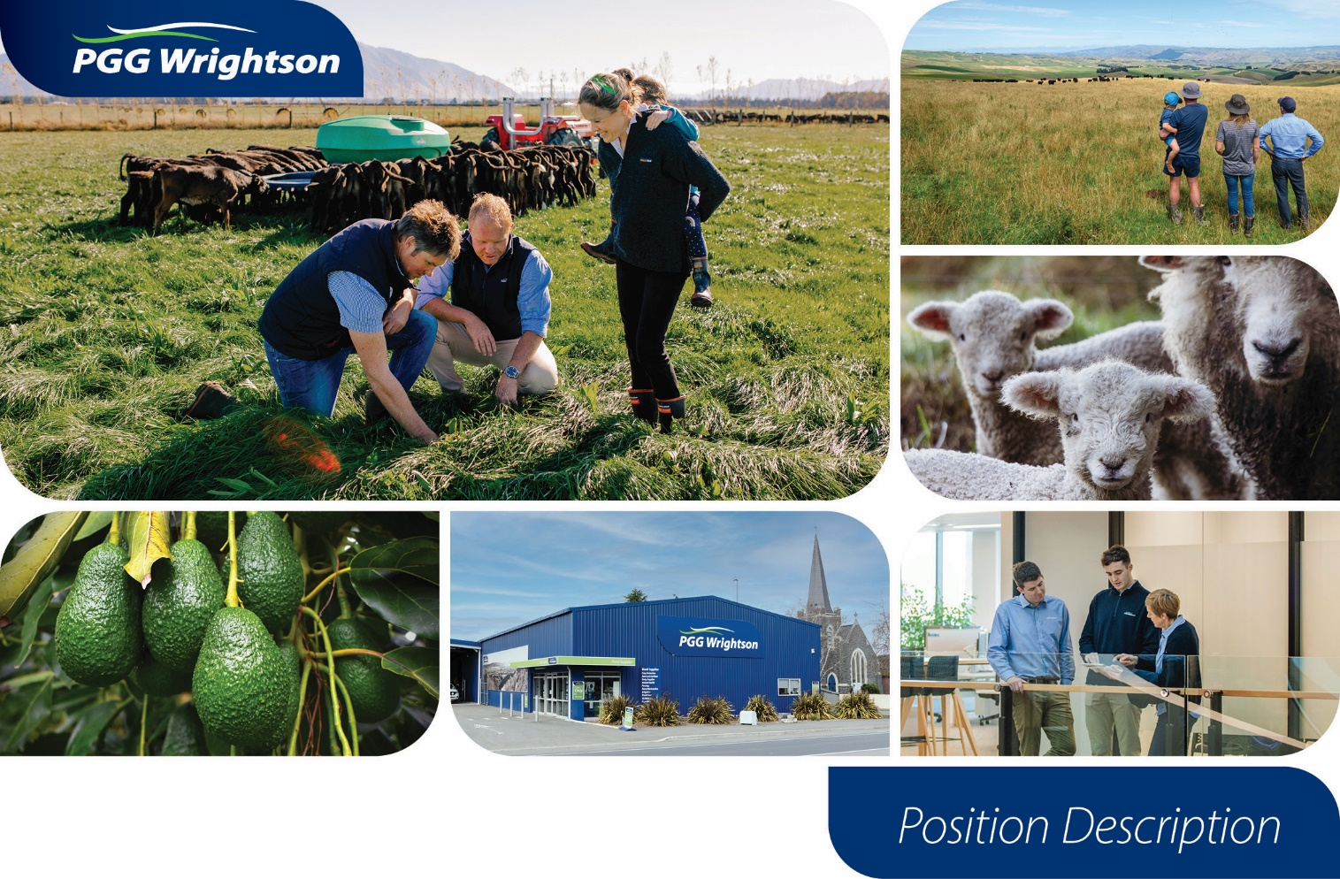
Role Details

Category Manager

Responsible to: National Manager - Retail Supply Chain
Business unit: Retail & Water / Supply Chain
Direct reports: No
Position Contribution
The Category Manager ensures that PGG Wrightson (PGW) has a market relevant, technically excellent, profitable, and strategically cohesive retail product offering in the designated categories. The Category Manager ensures the effective distribution and supply of this product offering across PGW’s retail network.
The role holder successfully influences senior stakeholders, manages mutually beneficial relationships with external supplier partners, including the negotiation of commercial agreements, and works in partnership with PGW sales, technical, marketing, finance and logistics teams to achieve superior category performance, commercial success and best practice processes.
Stakeholder Relationships
External  Suppliers  Transport, logistics and procurement specialists  Product and procurement specialists  Animal Production Industry Groups | Internal  Retail & Area Sales Managers, Key Accounts, Retail & Water Store Network  Technical Team  Supply Chain Team  Agritrade Team  Corporate functions: Marketing, Finance and Legal


Key Accountabilities

Category Leadership
- In partnership with sales, technical, marketing and logistics teams, develop the category strategy and the supporting business, sales and marketing plans
- Ensure product categories reflect current trends, research and are responsive to demand
- Build an in-depth knowledge of competitors, potential threats and other external drivers that will impact the category, and share this knowledge across the Retail & Water unit
- Be seen as an expert in the category, working with sales leaders to ensure category strategies, pricing policies and processes are well understood and supported
- Develop and maintain relationships with key supply partners to achieve superior category performance, commercial success, improve processes, gain efficiencies and implement best practice
- Manage distribution and supply performance to ensure product fulfilment with management of price and demand forecasting, planning, sourcing and availability of product, inventory levels, replenishment lead time, asset management, defective goods, regulatory requirements
- Actively manage category issues, including commercial product claims or supplier legal issues, in partnership with the sales, finance, legal and marketing teams
- Anticipate, manage, mitigate and monitor risk within given categories
Financial Performance
- Maximise sustainable earnings of categories by setting and achieving plans (Strategic, sales, financial)
- Negotiate Terms of Trade and Commercial Agreements that maximise margins, manage costs and ensure service delivery
- Prepare individual quotes, costings, pricing, deals as required
- Achieve budget, maximising sustainable earnings and achieving EBIT, rebate and working capital targets
- Review results versus forecast. Investigate and analyse sales, pricing and rebate data in order to develop and implement solutions for cost mitigation, operational efficiencies, rebate enhancement or improved cashflow
- Maximise all opportunities by leveraging across total company spend.
- Operate within and help enforce Delegated Levels of Authority (DLA), complete monthly reporting and share results
Teamwork
- Collaborate, communicate and actively partner with colleagues across PGW, in particular across the Supply Chain, Sales, Technical, Finance and Marketing teams
- Communicate the category strategy and plans across Retail & Water regularly and widely
- Develop strong relationships with suppliers. Clearly communicate expectations and PGW commitments to suppliers.
Business Planning
- Provide input into developing the Supply Chain strategy and delivering upon it within agreed timeframes
- Participate in the annual budgeting process
- Provide monthly feedback and reporting on category progress, challenges, priorities and performance against results, including rebate reports, category sales and category reviews
- Critically analyse systems and procedures to identify opportunities for process improvement
- Contribute ideas to further develop the business

Health & Safety
- All activities undertaken in accordance with PGW’s health and safety policy and procedures
- Ensure compliance with responsibilities under the Health and Safety at Work Act (2015) and any amendments
- Ensure compliance with requirements of the Motor Vehicle Policy, specifically the PGG Wrightson Safe Driver Pledge
- Actively participates in the hazard identification and risk management process
- Report all accidents, incidents and near misses in a timely manner
- Raise any health and safety related issues or areas of concern with manager or Health and Safety representative as soon as possible
- Engage in any Safety, Wellbeing & Environment related training and complete all applicable course work
- Comply with client site requirements

Other Duties
- Undertake Supply Chain project work
- Complete other duties as reasonably directed by the Manager from time to time
- Complete tasks and projects in a competent and timely manner in accordance with directions

Qualifications, Experience & Skills
Essential
- Minimum 5 years’ experience of category management and supply chain management
- Minimum 5 years’ experience and strong technical understanding of Production Animal Health
- Experience in supplier relationship management including negotiating commercial contracts
- Financial and sales analytical skills, including the ability to integrate internal and external data sources and translate this into meaningful insights that inform commercial decisions
- Strong communication skills, including presenting, influencing, collaborating and writing business cases
- An appropriate tertiary qualification, for example, agriculture, finance, logistics, business administration
- Strong computer literacy and working knowledge of Microsoft Office products
Desirable
- Knowledge of Production Animal Nutrition
- Retail or merchandising experience
- Experience working with industry or government bodies
- An understanding of emerging trends and regulations linked to environmental, sustainability and quality assurance in the rural sector

Our Values
