
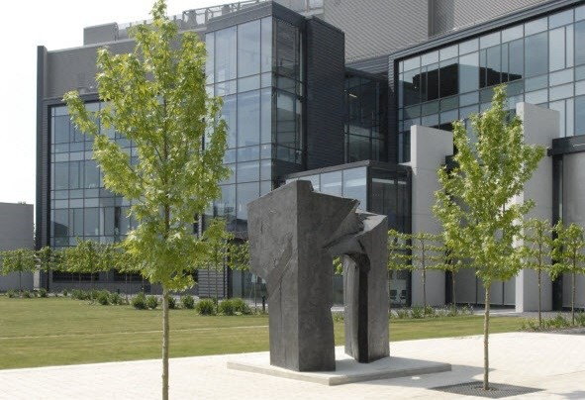
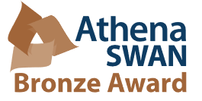

Director of Bone Mineral Research and Imaging

Part time 0.2 FTE
Department of Veterinary Medicine

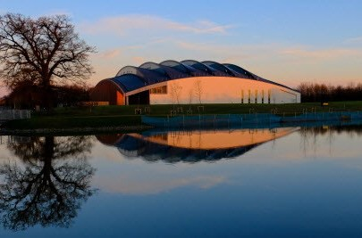
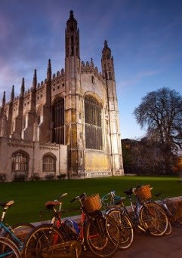
Job Reference: PP29569

The role

Salary Director of Research Grade 12
£73,779.00 pro rata

Staff group:
Research

Contract:
Fixed Term 2 years in the first intstance

Location:
Central Cambridge and West Cambridge

Department:
Veterinary Medicine

Responsible to:
Head of Department

Working pattern:
Part time 0.2FTE

Purpose of the role

A Director of Research is required on a 20% FTE basis to lead and maintain the unit’s national and international reputation for research excellence around the established research facility at the Department of Veterinary Medicine. The facility requires an established academic who can, through originality in research and scholarship, contribute to the advancement of knowledge in the area, while also providing the appropriate leadership required for academic and commercial interaction to bring collaborators, users and commercial partners to use the facility. The purpose of this role is thus to provide expert leadership, drive income generation and a strategy for efficient and successful utilisation of the Facility as well as seeking strategies to enhance outputs and impact for University users.

The facility currently employs two part time senior post-doctoral workers who require specific high-level direction. The roleholder will also participate in the overall contribution of the Department, such as in as the next REF exercise and the development of overall research strategy.

Key responsibilities
1 | To provide academic leadership, including grant leadership and collaboration
2 | To provide leadership for the Facility in relation to commercial organisations utilising its services
3 | Promote the opportunities within the facility to members of the Department, to academics around West Cambridge and the School of Biological Sciences and the wider university.
4 | Ensure that staff managing the facility are supported to deliver their specific objectives
5 | To work with the Department and HoD to ensure the needs of the facility including staffing and other forms of investment, are fully met
6 | Investigate and respond to accidents, incidents, health conditions and complaints relating to health and safety

Person specification

 | Essential | Desirable
Education
Educated to at least PhD or equivalent in a relevant field | ✓
Skills
Excellent team leadership and stakeholder management skills. | ✓
Knowledge and experience within the fields of (a) microscopy (b) flow cytometry and imaging flow cytometry (c) ICP analysis and (d) mineral synthesis and particle analysis to provide pro-active strategies for facility staff and users to optimise outputs. | ✓
Knowledge and experience should be evidenced by a strong academic publication record | ✓
Leadership experience and achievements
Extensive group leadership experience of managing an academic group, including leading research grants and interactions with the commercial sector. | ✓
Commercial experience should extend to dealing with intellectual property (IP) issues, translational impact and facility management |   ✓
Demonstrable understanding of how University Departments work in the context of a research environment, with previous team and facility management experience |   ✓

The Department

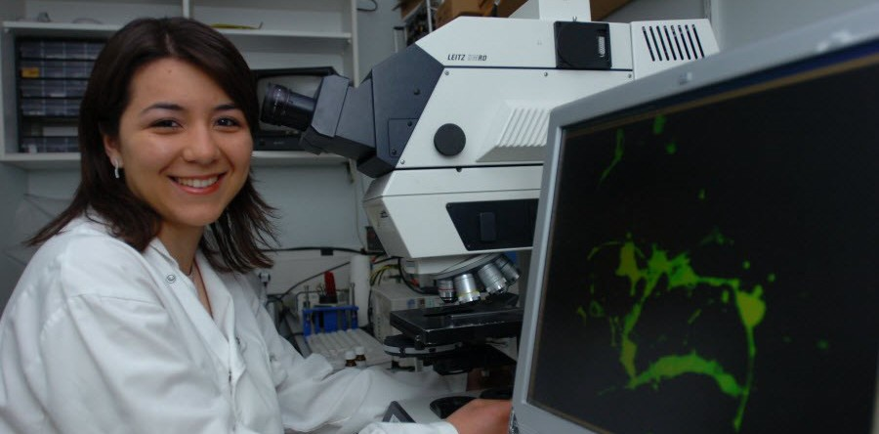

Department of Veterinary Medicine

Mission statement
To deliver excellence in veterinary education and biomedical research, and to address the challenges to the health and welfare of animals, humans and the environment in the 21st century.

The Department of Veterinary Medicine has over 250 employees (225 FTE), 35 clinical training scholars, 65 clinical veterinary students in each cohort and 40 graduate students. We aim to be internationally competitive in research, to foster collaborations with academia and industry, and to ensure that our undergraduate and postgraduate teaching and clinical work benefits from research excellence.

Research
The Department provides an academic environment of the highest quality, within which world-class research are performed. As a constituent Department of the University of Cambridge we have excellent opportunities for collaboration with other world-class Departments and institutions within the University, amongst them the Clinical School at Addenbrooke’s Hospital, the CRUK Cambridge Research Institute, and the Departments of Pathology, Zoology, Biochemistry, Genetics, Pharmacology, and Physiology, Development & Neuroscience, as well as non-University institutions located in the Cambridge area, such as the Wellcome Trust Sanger Institute, the MRC Laboratory of Molecular Biology, the MRC Biostatistics Unit and the BBSRC Babraham Institute.

Our research encompasses basic and applied biomedical and veterinary clinical sciences ranging from the molecular to the population level and is configured into 3 research themes (Infection & Immunity, Disease Dynamics and Systems Pathology). The Department has an annual research income of around £7M, and in the 2014 and 2021 Research Excellence Framework contributed to Unit of Assessment 6 (Agriculture, Food and Veterinary Science).

We put particular emphasis on research collaboration between the basic sciences and clinical research. This is promoted through a series of weekly seminar presentations attended by all research staff and clinicians in the Department, and by annual Departmental research days. We have a strong and varied seminar series which hosts academic visitors from all over the world in many different disciplines.

Teaching, Hospital and clinical provision

The Department of Veterinary Medicine undertakes a wide range of teaching and activities on its site on the University’s West Cambridge campus. As part of the research-lead University of Cambridge, basic, applied and clinical research is core to the ethos of the Department. Teaching of clinical veterinary students is also a key priority. Additionally, the Department undertakes post-graduate training in clinical specialisms and research, leading to specialist Diplomas and PhDs. Much of this undergraduate and postgraduate training is performed on site in The Queen’s Veterinary School Hospital. We have a national and international reputation for excellence in veterinary science and education, and in 2021 ranked seventh in the world in the Top QS Universities ranking.
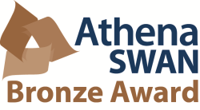

The Department subscribes to the principles of the Athena SWAN Charter, which recognises commitment to advancing women's careers in science, technology, engineering, maths and medicine (STEMM). The Department was awarded an Athena SWAN Bronze award in November 2013 which was renewed in 2017 and again in 2020.

The School of the Biological Sciences


The School of the Biological Sciences is one of the six
Schools that are responsible for delivering teaching and
research and the administration of those activities within the University.

About the School
The School of the Biological
Sciences encompasses the Faculty Board of Biology and the Faculty Board of Veterinary Medicine and is represented on the Faculty Board of Clinical Medicine. It has responsibilities across three Triposes (the Natural Sciences Tripos, Medical and Veterinary Sciences Tripos and Psychological and Behavioural Sciences Tripos) and is responsible for graduate
education within the
Departments and University
Partner Institutes that sit within the Faculty of Biology.
The School collaborates closely with the School of Clinical Medicine. At the graduate level the Graduate School of Life Sciences looks strategically at graduate provision and education across the two Schools and at the undergraduate level the Graduate Committee and Medical Education Committee with the Clinical School work closely together.
The School is a key player in the Cambridge Conservation Initiative as well as the majority of Cambridge Strategic Initiatives. The School is associated with the Museum of Zoology and the
Botanic Garden. Key officers of
the School plus details of relevant Research Ethics
Committee (Human Biology, Psychology) can be found on the School's website: https://
www.bio.cam.ac.uk/.
Various subcommittees report to
the Council, as required.
Formal representation on the Council of the School (its most senior decision-making body) is outlined in Chapter 8 of the University's Statutes and
Ordinances. Heads of School Institutes, as well as Heads of Departments, are currently co- opted on to the Council,
together with representatives of the three Faculty Boards. In
addition, the Head of the
Botanic Gardens and a
representative from the School of Technology attend as
observers.

Athena SWAN
The Athena SWAN Charter was launched in June 2005 to
recognise and reward
commitment to advancing the careers of women working in higher education in science, technology, engineering, mathematics and medicine
(STEMM). Although developed to address the lack of female
representation in these subjects, the activities that support the Charter will contribute towards a more positive working
environment for all. For more information on the history and principles of the Athena SWAN Charter please visit the Athena SWAN website.
The University of Cambridge was a founder member of Athena SWAN Charter and the University won its first award in the inaugural round of March 2006. Since then the University has successfully renewed its
Bronze Athena SWAN award in 2009 and 2012 and in 2014 achieved a Silver Athena SWAN award. Many of the
Departments in the School of Biological Sciences hold awards at Bronze or Silver level and the School continues to support the Athena SWAN process across all subjects.

Terms of appointment

Tenure

2 years in the first instance

Hours of Work
The hours of work for the position are part time 20% FTE, Flexible working can be accommodated

Pension
You will automatically be enrolled to become a member of USS (Universities Superannuation Scheme) – a defined benefit pension scheme. For further
information please visit:
www.pensions.admin.cam.ac. uk
Annual leave
The Annual leave allowance for Research Staff is 41 days per annum including Public Holidays, this is pro rata for part time staff

General information
Right to work in the UK
We have a legal responsibility to ensure that you have the right to work in the UK before you can start working for us. If you do not have the right to work in the UK already, any offer of employment we make to you will be conditional upon you gaining it.
Health declaration
Once an offer of employment has been made the successful candidate will be required to complete a work health declaration form.
Qualifications
The person specification for
this position lists qualifications / experience that are essential and/or desirable. Please note that if you are offered the post you will be asked to provide your relevant original certificates of these qualifications.
References
Offers of appointment will be subject to the receipt of
satisfactory references.
Equality and Diversity
We particularly encourage women and /or candidates from a Black, Asian and Minority Ethnic background to apply for this vacancy as they are currently under represented at this level within our University.
Information if you have a disability
The University welcomes applications from individuals with disabilities. We are committed to ensuring fair treatment throughout the recruitment process. We will make adjustments to enable applicants to compete to the best of their ability wherever it is reasonable to do so and, if successful, to assist them during their employment. Information for disabled applicants is available at www.admin.cam.ac.uk/offices/
hr/staff/disabled/
We encourage you to declare any disability that you may have, and any reasonable adjustments that you may require, in the section provided for this purpose in the
application form. This will enable us to accommodate your needs throughout the process as required. However, applicants and employees may declare a disability at any time.
If you prefer to discuss any special arrangements connected with a disability, please contact the Department of Veterinary Medicine HR co-ordinators at hr.enquiries@vet.cam.ac.uk

The University


The University of Cambridge is one of the world’s oldest and most successful universities. We are a renowned centre for research, education, and scholarship that makes a significant contribution to society. The University is consistently ranked amongst the top universities in the world. Our affiliates have won more Nobel Prizes than any other University.

Our sustained pursuit of academic excellence is built on a long history of first-class teaching and research within a distinctive collegiate system.
For eight centuries our ideas and innovations have shaped the world. Our principal goal is to
remain one of the world’s leading universities in an increasingly competitive global higher
education sector. Today the University of Cambridge is at the centre of a cluster of over 4,300 businesses employing 58,000 people.
Our capital investment projects include the West
Cambridge site, the North West Cambridge
development and the growth of the Biomedical
Campus in the south of the city. The North West Cambridge development and the growth of the Biomedical Campus in the south of the city. The North West Cambridge development includes
the opening of a primary school – the first in the UK to be managed by a University. So we are
deeply embedded in, and committed to serving, our local community. These are all conspicuous signs of a University that is not only adapting to new needs, but also anticipating the future.

Our mission is to contribute to society through
the pursuit of education, learning, and research at the highest international levels of excellence. Our core values are:

  - freedom of thought and expression; and
  - freedom from discrimination.

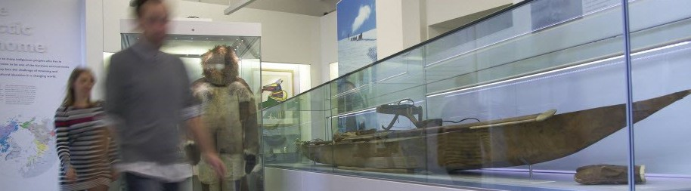
About us

The University is one of the world's leading academic centres.

It comprises 150 faculties and departments, together with a central administration and other institutions.
Our institutions, museums and collections are a world-class resource for researchers,
students and members of the public representing one of the country’s highest concentrations of
internationally important collections.
The University has an annual income of £1.66 billion. Research income, won competitively from the UK Research Councils, the European Union (EU), major charities and industry, exceeds £400 million per
annum and continues to grow.

The Colleges and the University remain committed to admitting the best students regardless of their
background and to investing considerable resources both in widening access and financial support.
The 31 Colleges are self-governing, separate legal entities which appoint their own staff. Many
academic staff are invited to join a College as a
Teaching Fellow, which provides a further social and intellectual dimension. The Colleges admit students, provide student accommodation and deliver small group teaching.

The University awards degrees and its faculties and departments provide lectures and seminars for students and determine the syllabi for teaching and conducting research.

The University’s estate is undergoing the most significant transformation in its history. Cambridge has been able to create a new science and
technology campus to the west of the city centre, and is now expanding further to the north west of
Cambridge including investing in affordable homes for University key workers and community facilities.
Even with our continued development, the University remains within walking or cycling distance across the campus. The University is a major partner on the Cambridge Biomedical Campus and we continue to
redevelop our historic city centre sites demonstrating our determination to ensure that we can offer the
best facilities and opportunities for our staff and students.

Our instinct for seeking out excellence and setting up enduring and mutually beneficial collaborations has led us to establish strategic partnerships across the
globe. Whether it is the successful Cambridge-Africa Programme involving universities in Ghana, Uganda and elsewhere on the African continent; or the close association with the government of India to pursue new research in crop science; or the creation, with Germany’s Max Planck Institutes, of a Cambridge-
based centre for the study of ethics, human economy and social change – international partnerships are
now an inextricable part of the University’s make-up.

Our ideas and innovations have shaped the world. Our campaign, 'Dear World... Yours, Cambridge', will raise
£2 billion to help us shape all our futures.

Working at the University

Working at Cambridge you will join a diverse, talented and innovative community, with more than 18,000 students and over 11,000 staff from all walks of life and corners of the world.

The University continually explores strategies to attract and retain the best people. It is
committed to supporting its staff to achieve
their best. We are a fair, diverse and inclusive society and we believe our staff are our greatest asset. There is strong commitment to
developing institutional leadership and supporting and encouraging staff development at all levels. Furthermore, the University’s Athena SWAN award recognises and celebrates good
practice in recruiting, retaining and promoting women. We offer a variety of roles including
academic, research, professional, managerial and support roles. We also offer extensive benefits
and excellent learning opportunities within a stimulating working environment. The University has signed up to the Race Equality Charter, a
notional framework for improving the
representation, progression and success of
minority ethnic staff and students within higher education.
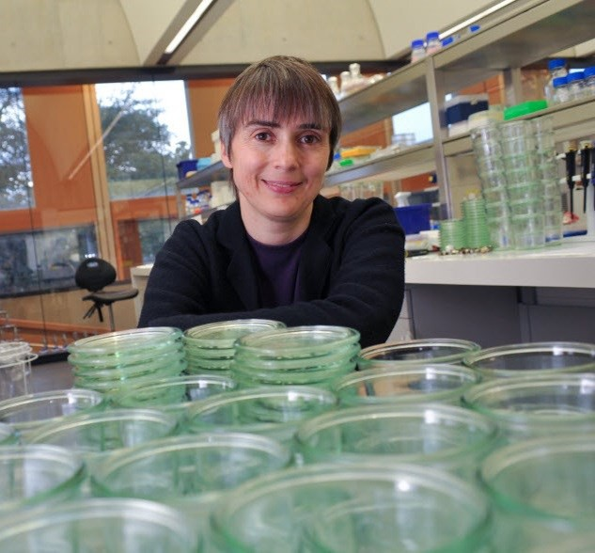

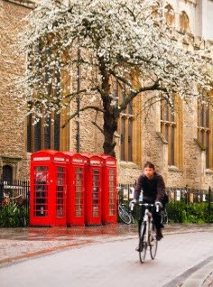


Living in Cambridge

Cambridge is rich in cultural diversity. From beautiful University and College buildings, museums and art galleries, quaint gardens and punts on the River Cam, to a vibrant
restaurant and café scene, our employees are surrounded by the wonderful features of this unique city.

If you prefer the faster pace of life, London is a 45 minute train journey away. For those travelling from overseas, Stansted Airport is just 45 minutes away and Heathrow Airport under 2 hours away.

The University is a short distance from a host of other
attractions such as Ely Cathedral, Newmarket Races and various wildlife parks and stately homes. Cambridge is also within easy reach of the beautiful Broads and coastlines of Norfolk and
Suffolk.

Further information about attractions in and around Cambridge can be found at Visit Cambridge, the official tourism website for the city.

What Cambridge can offer

We offer a comprehensive reward package to attract, motivate and retain high performing staff at all levels and in all areas of work.

The University offers a wide range of competitive
benefits, from family leave entitlement, to shopping and travel discount schemes. Our generous annual leave package contributes to the positive wellbeing
of our University employees. Sabbatical leave enables
academics to focus on research and scholarship,
whilst still maintaining their full salary. The University also has a career break scheme for academic and
academic-related staff, with additional flexible working policies for all other staff.

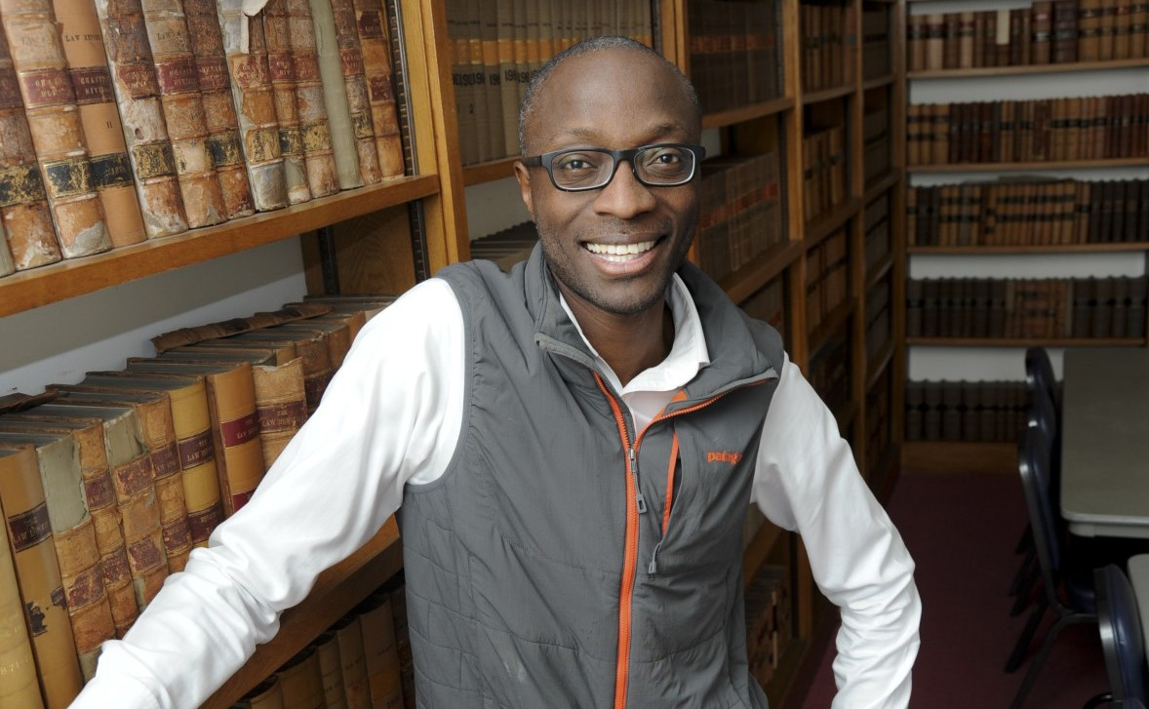

CAMbens employee benefits
We offer a CAMbens scheme for University
employees, providing access to online and in-store shopping discounts and cashback. With more
than 2,000 participating retailers, employees can save money on a wide range of household expenses, from groceries
and clothes, to holidays and insurance and much more. A range of local discounts are also available, helping employees to save money whilst also supporting local Cambridge businesses. CAMbens Cars and CAMbens Cycle to Work salary sacrifice schemes are also available, which enable employees to save money on transport costs. A 10% discount
rate on the purchase of train season tickets, bulk buy tickets and an interest free travel to work loan are
also available for staff of the University.

Family-friendly policies
The University recognises the importance of supporting its staff. We have a range of family-
friendly policies to aid employees’ work-life balance including a generous maternity, adoption and shared parental leave entitlement of 18 weeks full pay and
emergency family care support via My Family Care. In addition, our highly regarded workplace nurseries,
childcare vouchers, a childcare salary sacrifice
scheme and a high quality holiday play scheme are available to help support University employees with caring responsibilities. The Newcomers and Visiting Scholars Group is an organisation within the
University run by volunteers whose aim is to help
newly arrived wives, husbands, partners and families of Visiting Scholars and members of the University to settle in Cambridge and give them an opportunity to meet local people. The Office of Postdoctoral Affairs supports the postdoctoral community within Cambridge. Further details are available here: https://
www.opda.cam.ac.uk/

Development opportunities
We support new employees to settle in through various activities. The encouragement of career
development for all staff is one of the University's values and we put this into practice through various services and initiatives. Our Personal and Professional Development Department provides development
opportunities and courses for all University
employees. These include face-to-face sessions,
online learning modules and webinars. Employees may also apply for financial support to undertake training that will lead to a qualification. We offer reduced staff fees for University of Cambridge
graduate courses and the opportunity to attend
lectures and seminars held by University departments and institutions. The CareerStart@Cam programme
also supports employees in assistant staff roles who do not hold higher education qualifications to
develop their skills, experience and qualifications.

What Cambridge can offer

Pay and benefits
The University salary structure includes automatic service-related pay progression in many of its
grades and an annual cost of living increase. In addition to this, employees are rewarded for
outstanding contribution through a number of
regular pay progression schemes. The University offers attractive pensions schemes for employees, with an additional benefit of a salary exchange
arrangement providing tax and national insurance savings. Payroll giving is also a simple, tax-efficient way for employees to make monthly donations to charity.



Your wellbeing
The University’s Sport Centre, Counselling Services and Occupational Health are just some of the support services available to University employees to promote their physical and mental wellbeing.
There are many societies in Cambridge catering for almost every taste and interest. Whether you want
to take part in a sport, participate in music or drama, pursue a hobby, or join a political group, you will
almost certainly find that a society exists for this
purpose. The University also hosts the Cambridge
Science Festival and Cambridge Festival of Ideas, as well as Open Cambridge weekend, which together
attract over 50,000 visitors per year. The festivals are a great opportunity to get your first taste of public engagement, through volunteering, supporting
Whether it is understanding the molecular basis of neu- rodegenerative diseases, or helping farmers in India increase their yield, or discovering better ways to live in large cities – I know that what we do in Cambridge af-
fects lives, and livelihoods, the world over.
Vice Chancellor Emeritus, Professor Sir Leszek Borysiewicz, 2016
hands-on activities or proposing a talk.

Equality & diversity
The University has built its excellence on the
diversity of its staff and student community. We aim to be a leader in fostering equality and
inclusion, and in promoting respect and a sense of belonging for all. We encourage applications from all sections of society. All appointments are made on the basis of merit. We have an Equal
Opportunities Policy, along with a range of diversity networks for women, black and minority ethnic and lesbian, gay, bisexual and transgender staff. More
details are available here:
http://www.equality.admin.cam.ac.uk/

Relocating to Cambridge
The University Accommodation Service exists to
help employees in their search for a rental home in Cambridge. A new University development at North West Cambridge called Eddington offers subsidised rented accommodation to University staff. The
development consists of high quality furnished one and two bedroom apartments. For more information about the development and how to apply please visit the website: www.nwcambridge.co.uk
The importance of helping individuals settle into a new area is also recognised by the University. The Shared Equity Scheme https://
www.hr.admin.cam.ac.uk/pay-benefits/cambens-
employee-benefits/financial/shared-equity-scheme provides financial assistance to qualifying new members of staff with the purchase of living
accommodation, where they have to relocate to
take up their appointment. Removal expenses are also available for qualifying new members of staff.



How to apply
Applications should be submitted online via the University of Cambridge jobs page www.jobs.cam.ac.uk by clicking “Apply online” in the job advert. You will need an email address to register for our online system.

Enquiries
XXXXXXX
If you have any queries regarding the application process please contact XXXXX
The closing date for applications is: XXXXX
Interviews for the role will take place on XXXXX

UNIVERSITY OF
CAMBRIDGE

